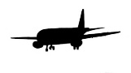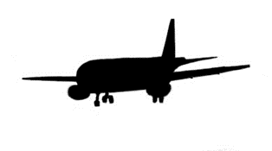
Franklin-Hart County Airport Authority
P.O. Box 392
Carnesville, GA 30521
823 Airport Rd
Canon, GA 30520

April 19, 2022

Franklin Hart Airport Authority
Regular Meeting
Agenda
- 2:00 PM Call to Order
- Establishment of Quorum
- Prayer
- Pledge of Allegiance
- Approve Agenda
- Secretary Report
  - Approve Minutes
    - March 3, 2022
- Treasurer Update
  - Operating Account
  - Fuel Account
  - Phase 2 Matching Funds
- Old Business
  - Airport Mowing Update (Mike Ward) – IGA with Franklin County
  - FYE 2021 Audit by Jay Green
  - Approach Obstruction Removal
- New Business
  - Shelter for Courtesy Car
- Executive Session
- Resume Meeting
  - Action items from executive session
- Adjourn

